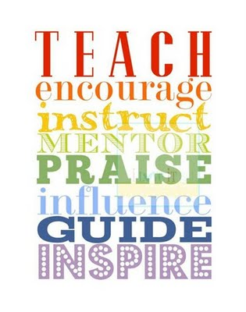

RSVP’s Virtual Youth Mentoring Program Summary

Goals for Youth Participants: Support and enhance individual, personal development including self-esteem, building relationships, goal-setting, researching future opportunities
Target Grades: 3rd – 6Th grade when they begin
Key Partners: Parents/Guardians, community programs, schools
Mentor Requirements:
- The first step for mentors is to obtain clearances. Those required include the PA criminal background; a PA DHS child abuse clearance; FBI fingerprinting and a check of the National Sex Offender Registry database; also required is an online Act 126 mandated reporter training and three references including one family member and two personal
Program Outline:
Mentors and mentees will meet online 2-4 times per month (only 2x/month required) on a regular schedule for 9 months. These virtual meetings will be scheduled via Zoom and after school because of the uncertainty of school schedules at this time. The match may be extended for a longer period if all parties are agreeable.
Pre-Match: Thorough volunteer screening, orientation and training for mentors; Interview with parent/guardians and/or referring partners to identify youths’ needs
Below are the central topics/focus of the bimonthly sessions:
- Pre-Match background work: Clearances, Orientation, Training
- First Match Meeting (Getting to know each-other, review of program, complete Goals Worksheet)
- Explore developmental assets and mentee’s ‘Sparks’
- Discuss behavioral issues through trauma-informed lens (focus on helping youth cope with anxiety and anger)
- Explore cultural diversity through holiday traditions and celebrations
- Discuss growth mindset and develop Strategy Box to achieve goals
- Work on SMART goal setting, review progress towards goals

Virtual Youth Mentoring Program Summary (continued)

- Build resiliency skills to handle difficult situations
- Discuss progress/completion of goals and future plans
- Celebration of achievements and match closure or planning for continuation

- Discussion topics will be enhanced through the use of the Epic! Education platform which includes books, audiobooks, and videos as well as other evidence-based resources available from organizations such as the National Mentoring Partnership (mentor.org), Search Institute (searchinstitute.org) and “Stepitup2Thrive” (http://stepitup2thrive.org/)

- Mentors will have detailed training on the Epic! Platform (getepic.com) and scheduling/meeting reminders will be sent to mentors and parent/guardians through the vcita for Education (vcita.com) platform. The Program Coordinator will facilitate the first match meeting. After that, the Program Coordinator will connect 1:1 with each mentor and parent at least once a month to get updates and provide training and resources.

- In months 4 and 8, the Program Coordinator will invite mentors to a voluntary “Chat & Chew” group session with other mentors to share challenges, successes and facilitate peer-learning opportunities. If areas of common interests emerge, the Program Coordinator will facilitate group enrichment activities.
Program Outcomes:
Pre and post surveys will be required from mentees, mentors, parent/guardians to include a review of mentees’ progress on individual, self-directed goals, examples of personal development, and personal testimonials.

