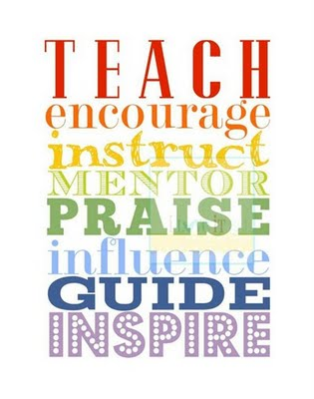

RSVP’s Virtual Youth Mentoring Program Summary

Goals for Youth Participants: RSVP's Youth Mentoring program is an evidence-based program through which mentors establish trust-filled, supportive connections with their students to help them increase their social-emotional/relationship skills, build self-esteem, learn how to set goals, and plan for their futures.

Target Grades: 3rd – 6Th grade when they begin

Key Partners: Parents, guidance counselors, or community agency representatives refer at-risk students they believe would benefit from one-on-one mentoring relationships. Students must want to participate and have written parental permission to do so.

Mentor/Pre-Match Requirements: The first step for mentors is to obtain clearances. Those required include the PA criminal background; a PA DHS child abuse clearance; FBI fingerprinting and a check of the National Sex Offender Registry database; also required is an online Act 126 mandated reporter training and three references including one family member and two personal.
Program Outline:
- Mentors and mentees will meet online for one (1) hour, twice (2x) a month on a regular schedule for 9 months. These sessions will be scheduled on Monday through Thursday between the hours of 3:45 and 8:30 p.m.
- These virtual meetings will be scheduled via Zoom during afterschool hours.
- The match may be extended beyond the initial 9-month period if all parties agree.
- There is a chance that mentoring could move to in-person meetings in the future depending on COVID-19 conditions and if all parties agree. These could include meetings at school or activities/events out in the community.

Topics and Activities Explored Each Month: (Numbers correspond to months; this may change based on late starts, etc. The ideal is that the first month is October.)
Pre-Match: Thorough volunteer screening, orientation and training for mentors; Interview with parent/guardians and/or referring partners to identify youths’ needs
Virtual Youth Mentoring Program Summary (continued)
- First Match Meeting (Getting to know each-other, review of program, complete Goals Worksheet)
- Diversity/Inclusion including holiday and family traditions and celebrations
- Explore developmental assets and mentee’s ‘Sparks’
- Discuss behavioral issues through trauma-informed lens (focus on helping youth cope with anxiety and anger)
- Discuss growth mindset and develop Strategy Box to achieve goals
- Work on SMART goal setting, review progress towards goals
- Build resiliency skills to handle difficult situations
- Discuss progress/completion of goals and future plans
- Celebration of achievements and match closure or planning for continuation

- Discussion topics will be enhanced through evidence-based resources available from organizations such as the National Mentoring Partnership (mentor.org), Search Institute (searchinstitute.org), “Stepitup2Thrive” (http://stepitup2thrive.org/) and the Child Welfare Information Gateway (https://www.childwelfare.gov/)

- Monthly, the Program Coordinator will invite mentors to a voluntary “Mentor Group Discussion” session to share resources, challenges, successes and facilitate peer-learning opportunities. There is also a group Facebook page where mentors can connect and share.
Program Outcomes:
Pre and post surveys will be required from mentees, mentors, parent/guardians to include a review of mentees’ progress on individual, self-directed goals, examples of personal development, and personal testimonials. To aid this process, a goal sheet will be completed at the first match meeting with input from the parent/guardian, mentee, and mentor.

